**Planning**

**Goals:**

* To create a scalable website delivering top tier fitness content and tools to its users.

**Objectives:**

* To create a visually appealing website
* To create a login system and account management system for users
* To keep record of user data for progress

**Target Audience:**

* The website will be targeted at the youth and middle aged groups.
* Fitness routines will be posted for both men and women i.e. the workouts will be unisex.
* Calorie counter may also be implemented for both genders and different age groups.

* 1. **Content:**
  2. The proposed content of the website is as follows :

* + Workout routines will be provided for both genders and different types of workouts will be on separate pages.
  + Nutrition guides and a calorie calculator will be provided.
  + A photo gallery will be added that will show the before and after results of consistent workouts
  + A contact page will also be provided.

**Additional Features:**

* + The website will include a navigation menu on the top and a banner behind it.
  + The website will also contain a fitness and health tip section on the left and a logo background on the right of the main page.

**Wireframing**

**Home page:**

**Banner Section**

* **Logo on the left**: clickable and redirects to the home page.
* **Navigation links**: Clearly labeled links (workouts, nutrition, health, gallery, contact us).
* **Login button on the right**: maybe with a hover effect to enhance interactivity.

**Background**

* Visually appealing but shouldn’t be distracting, maybe changes with time.

**Main Content Area (background image throughout this section)**

* **Right Side**: This will have the main content of the background.
* **Tips Box on the Left**: A Tips textbox which gives tips of the day for health.

**Workout Section**

* Different workout types mentioned with images.

**Tips Section**

* Dynamic tips to keep them engaging.

**Results Section**

* Testimonials and success stories here for credibility.

**Contact Section**

* Contact info mentioned here for users to reach out if needed.

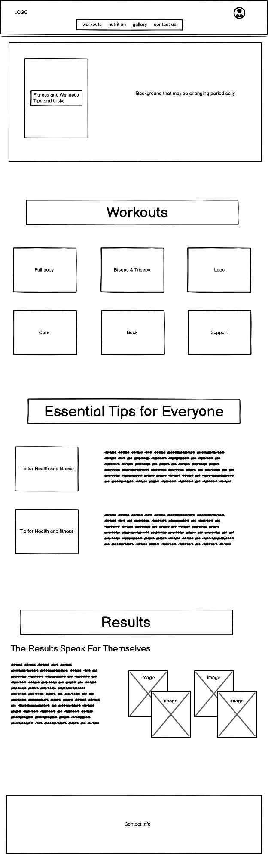

**Workouts page:**

**Banner Section**

* **Logo on the left**: clickable and redirects to the home page.
* **Navigation links**: Clearly labeled links (workouts, nutrition, health, gallery, contact us).
* **Login button on the right**: maybe with a hover effect to enhance interactivity.

**Background**

* Visually appealing but shouldn’t be distracting.

**Workout Section**

* Different workout types mentioned with images.

**Contact Section**

* Contact info mentioned here for users to reach out if needed.

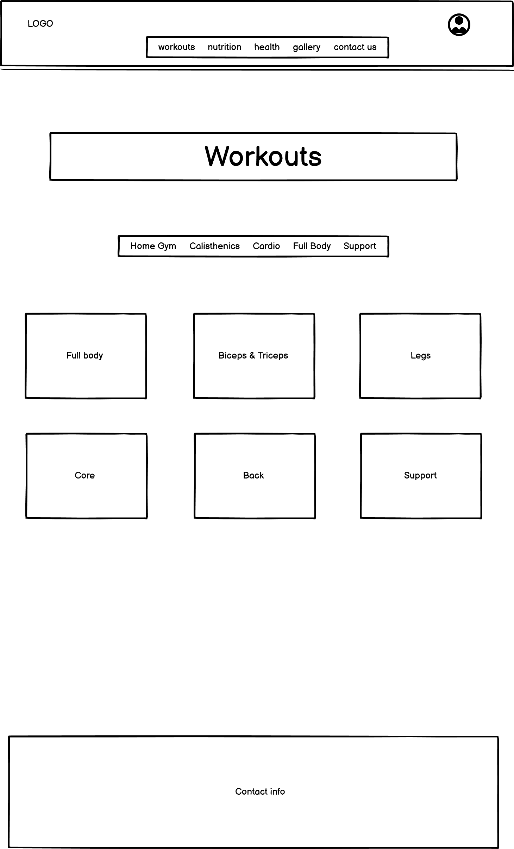

**Nutrition page:**

**Banner Section**

* **Logo on the left**: clickable and redirects to the home page.
* **Navigation links**: Clearly labeled links (workouts, nutrition, health, gallery, contact us).
* **Login button on the right**: maybe with a hover effect to enhance interactivity.

**Background**

* Visually appealing but shouldn’t be distracting, maybe changes with time.

**Main Content Area (background image throughout this section)**

* **Right Side**: This will have the calorie calculator and remarks.
* **Left Side**: This will have the input form for the calculator.

**Tips Section**

* Dynamic tips to keep them engaging.

**Contact Section**

* Contact info mentioned here for users to reach out if needed.

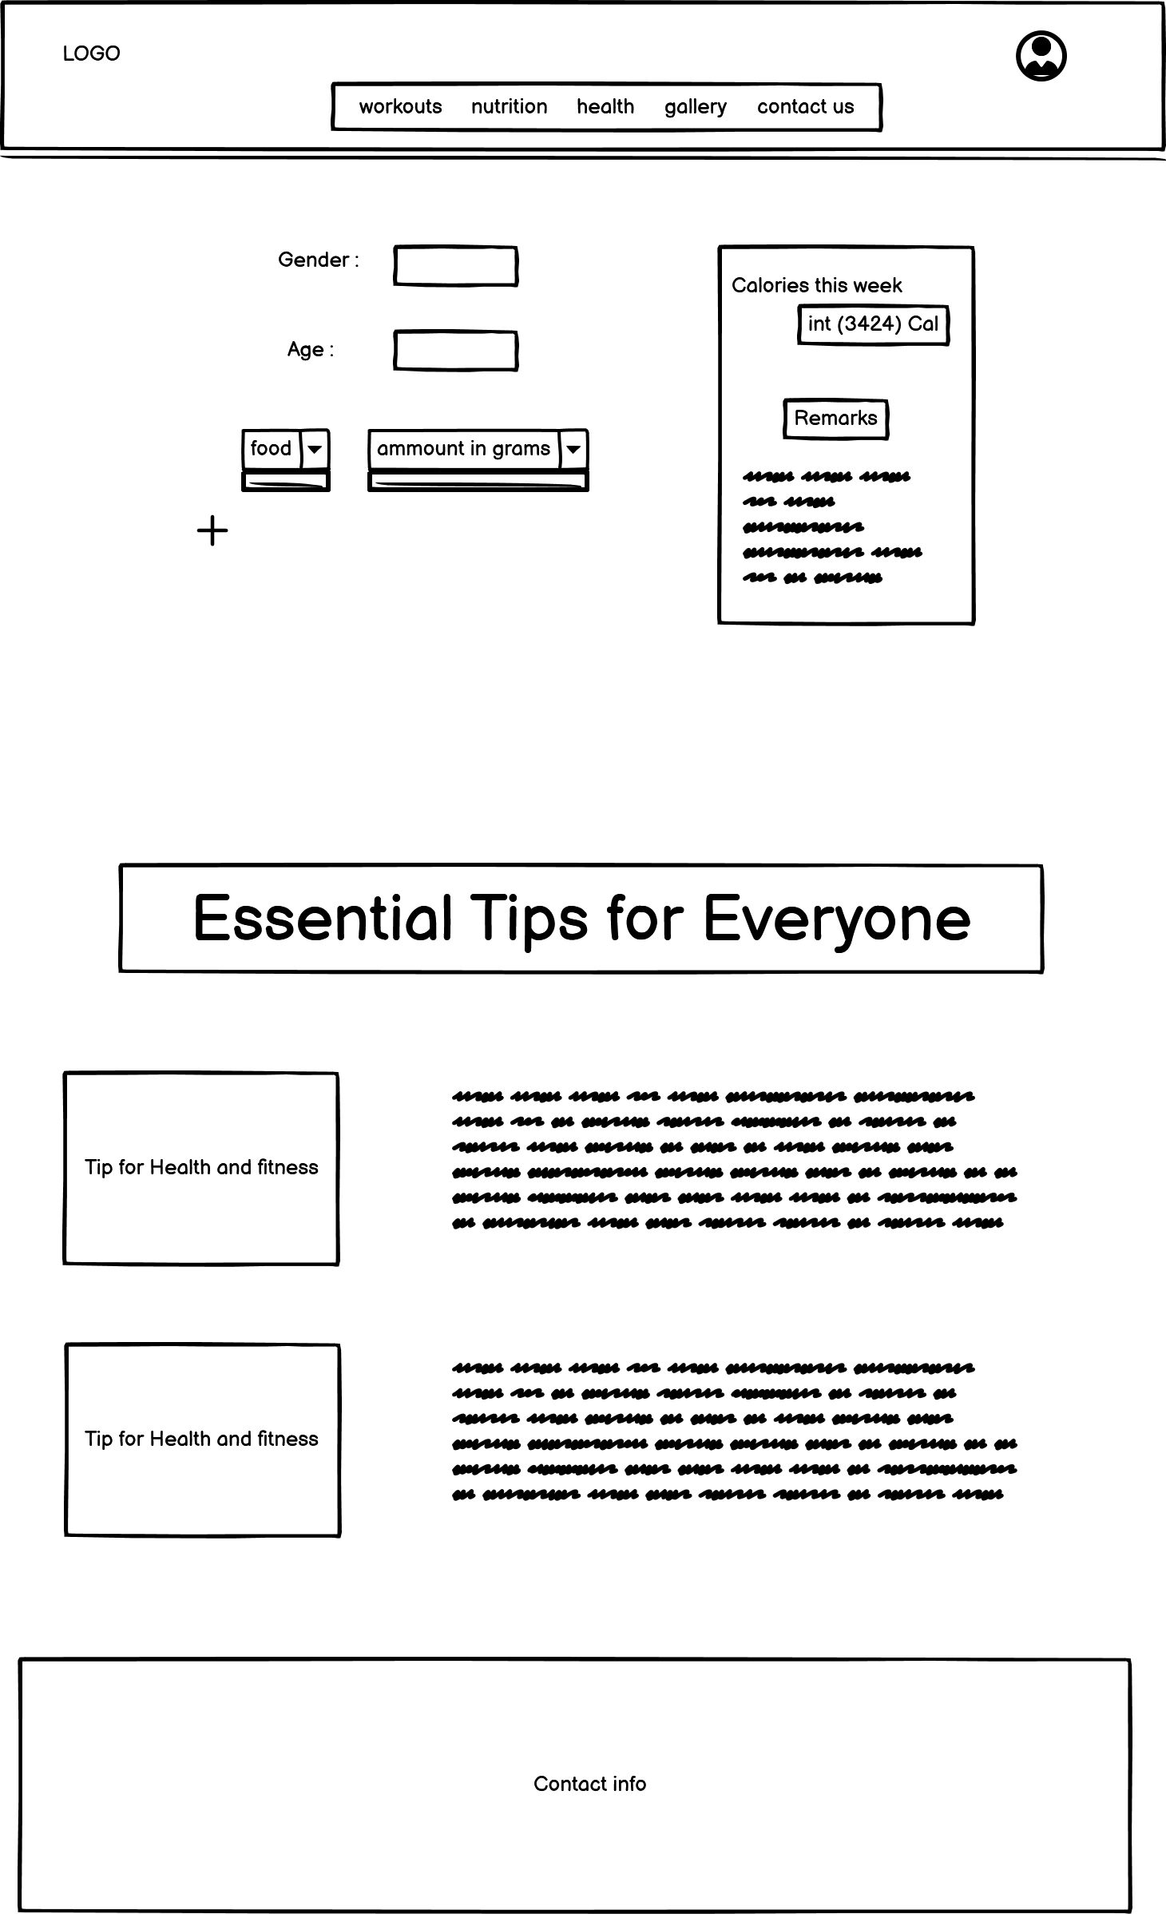

**Gallery page:**

**Banner Section**

* **Logo on the left**: clickable and redirects to the home page.
* **Navigation links**: Clearly labeled links (workouts, nutrition, health, gallery, contact us).
* **Login button on the right**: maybe with a hover effect to enhance interactivity.

**Background**

* Visually appealing but shouldn’t be distracting, maybe changes with time.

**Main Content Area (background image throughout this section)**

* **Left Side**: This will have the before and after images
* **Right side**: An engaging story or testimonial from the person.

**Contact Section**

* Contact info mentioned here for users to reach out if needed

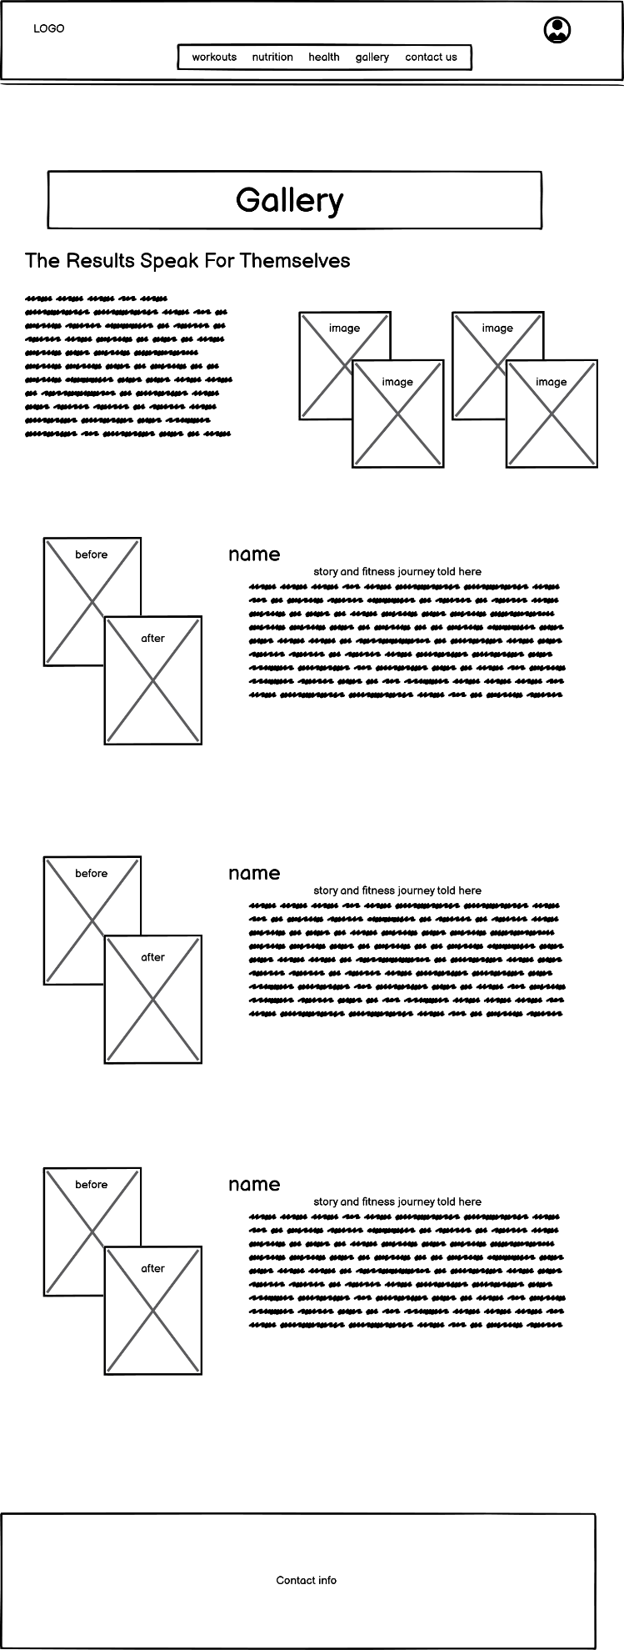

**Contact page:**

**Banner Section**

* **Logo on the left**: clickable and redirects to the home page.
* **Navigation links**: Clearly labeled links (workouts, nutrition, health, gallery, contact us).
* **Login button on the right**: maybe with a hover effect to enhance interactivity.

**Background**

* Visually appealing but shouldn’t be distracting, maybe changes with time.

**Contact Section**

* A detailed contact section for various needs, including social media pages.

